How to Summarize a Deposition? Examples of a Deposition Summary

* **May 30, 2024**
* **10:35 pm**

Table of Contents

1. [Introduction](https://legalconsultingpro.com/how-to-summarize-a-deposition-examples-of-a-deposition-summary/#elementor-toc__heading-anchor-0)
2. [What is a Deposition Summary?](https://legalconsultingpro.com/how-to-summarize-a-deposition-examples-of-a-deposition-summary/#elementor-toc__heading-anchor-1)
3. [The Objective of a Deposition Summary](https://legalconsultingpro.com/how-to-summarize-a-deposition-examples-of-a-deposition-summary/#elementor-toc__heading-anchor-2)
4. [Why do you need a Deposition Summary?](https://legalconsultingpro.com/how-to-summarize-a-deposition-examples-of-a-deposition-summary/#elementor-toc__heading-anchor-3)
5. [What are the types of Deposition Summaries?](https://legalconsultingpro.com/how-to-summarize-a-deposition-examples-of-a-deposition-summary/#elementor-toc__heading-anchor-4)
6. [How to Summarize a Deposition? The Deposition Summary Process](https://legalconsultingpro.com/how-to-summarize-a-deposition-examples-of-a-deposition-summary/#elementor-toc__heading-anchor-5)
7. [Deposition Summary Essential Requirements](https://legalconsultingpro.com/how-to-summarize-a-deposition-examples-of-a-deposition-summary/#elementor-toc__heading-anchor-6)
8. [Benefits of a Deposition Summary](https://legalconsultingpro.com/how-to-summarize-a-deposition-examples-of-a-deposition-summary/#elementor-toc__heading-anchor-7)
9. [Why do you need Deposition Summary Services?](https://legalconsultingpro.com/how-to-summarize-a-deposition-examples-of-a-deposition-summary/#elementor-toc__heading-anchor-8)
10. [Conclusion](https://legalconsultingpro.com/how-to-summarize-a-deposition-examples-of-a-deposition-summary/#elementor-toc__heading-anchor-9)



Introduction

In the intricate world of legal proceedings, clarity and efficiency are paramount. Deposition transcripts, often spanning hundreds of pages, can be overwhelming and time-consuming to review in their entirety. This is where deposition summaries come into play. A [deposition summary](https://legalconsultingpro.com/deposition-summarization/) is a powerful tool that distills lengthy transcripts into concise, digestible formats, enabling attorneys to quickly grasp the essential details and strategize effectively. Whether you’re preparing for trial, cross-examinations, or motions, understanding the role and benefits of deposition summaries can significantly enhance your legal practice. In this blog, we will explore the objectives, types, process, and benefits of deposition summaries, and discuss why outsourcing these services to experts like Legal Consulting Pro can be a game-changer for your firm.

What is a Deposition Summary?

A deposition summary is a meticulously crafted document that encapsulates the essence of a deposition transcript. It serves as a condensed version of the original testimony, extracting crucial details, key points, and significant exchanges. Think of it as a roadmap through the intricate terrain of legal proceedings, guiding attorneys toward relevant information without the need to navigate through hundreds of pages of transcripts. It is also known as a deposition digest.

The Objective of a Deposition Summary

At its core, the objective of a deposition summary is to simplify the review process for attorneys and litigation stakeholders. By distilling complex testimonies into digestible nuggets of information, it empowers attorneys to focus their attention on the most pertinent aspects of a case. This focused approach not only saves time but also ensures that critical details are not overlooked amidst the sea of legal jargon and intricacies.

Why do you need a Deposition Summary?

The need for a deposition summary (deposition digest) arises from the inherent challenges posed by lengthy deposition transcripts:

* **Efficiency:** With depositions often spanning hundreds of pages, a summary streamlines the review process, enabling attorneys to extract relevant information swiftly.
* **Clarity:** By presenting information in a clear, concise manner, a deposition summary eliminates ambiguity and ensures that key points are readily accessible.
* **Preparation:** Whether preparing for trial, cross-examinations, or motion hearings, a well-prepared summary equips legal teams with the insights they need to build a compelling case.
* **Focus:** By distilling voluminous transcripts into manageable summaries, attorneys can direct their attention towards strategic analysis and case development, rather than drowning in the minutiae of the deposition.

What are the types of Deposition Summaries?

Deposition summaries come in various formats, each catering to different preferences and requirements:

* **Page-Line Deposition Summary:** Aligns summarized content with specific page and line references from the transcript, facilitating easy cross-referencing and verification. A page-line deposition summary example is given below.

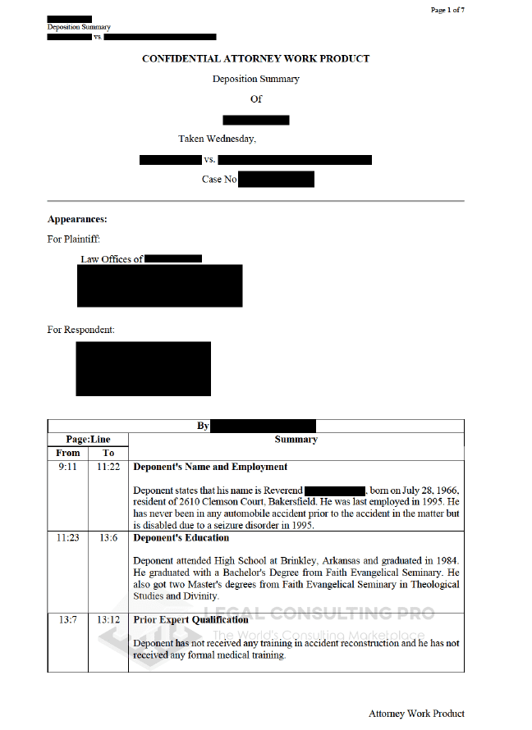Legal Consulting Pro Page-Line Deposition Summary Sample

* **Topical Deposition Summary:** Organizes information by topics or themes, allowing attorneys to navigate through the deposition based on their areas of interest. A topical deposition summary sample is given below.

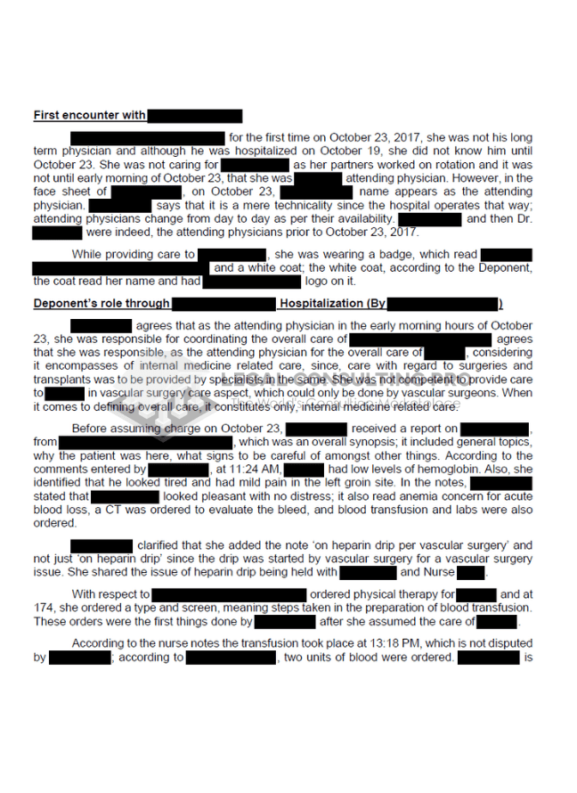Legal Consulting Pro Topical Deposition Summary Sample

* **Comprehensive Deposition Digest:** Offers a detailed overview of the deposition, covering all relevant points and nuances, ideal for in-depth analysis and case strategy development. A comprehensive deposition digest sample is given below.

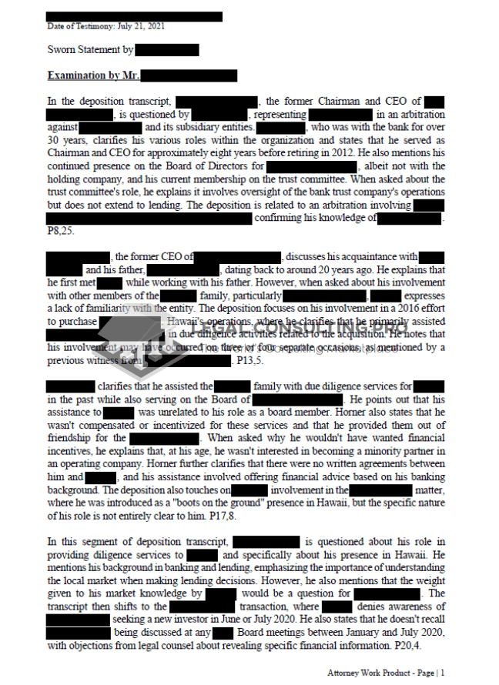Legal Consulting Pro Comprehensive Deposition Summary Sample

How to Summarize a Deposition? The Deposition Summary Process

Crafting a deposition summary involves a meticulous process to ensure accuracy and relevance:

1. **Transcript Review:** Thoroughly review the entire deposition transcript to gain a comprehensive understanding of the content.
2. **Key Point Identification:** Identify crucial testimonies, facts, and exchanges that are essential to the case.
3. **Organizational Structure:** Determine the appropriate summary format and organize the extracted information accordingly.
4. **Drafting:** Construct a draft summary that encapsulates the essence of the deposition while maintaining clarity and coherence.
5. **Review and Revision:** Carefully review the draft summary, revising and refining as necessary to ensure accuracy and completeness.

Deposition Summary Essential Requirements

For a deposition summary to fulfill its purpose effectively, it must meet certain essential criteria:

* **Accuracy:** The summary must accurately reflect the content of the deposition, ensuring that no critical details are misrepresented.
* **Clarity:** Information should be presented clearly and coherently, avoiding ambiguity or confusion.
* **Conciseness:** While comprehensive, the summary should be concise, focusing on relevant details without unnecessary verbosity.
* **Relevance:** Every aspect of the summary should contribute directly to the understanding and analysis of the case, eliminating extraneous or tangential information.

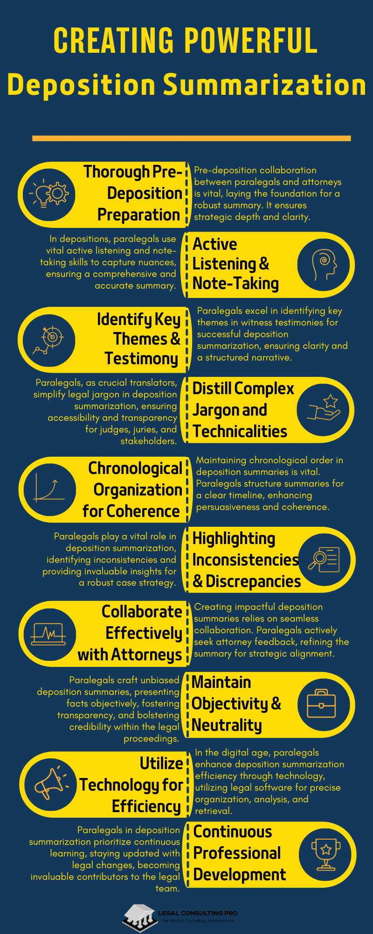Legal Consulting Pro Tips for Comprehensive Deposition Summarization Process

Benefits of a Deposition Summary

The advantages of utilizing deposition summaries extend far beyond mere convenience:

* **Time-Saving:** By condensing lengthy transcripts into succinct summaries, attorneys can expedite the review process, saving valuable time and resources.
* **Enhanced Focus:** A well-crafted summary directs attention toward critical aspects of the deposition, enabling attorneys to delve deeper into key issues.
* **Improved Organization:** Structured summaries provide a systematic framework for navigating through complex testimonies, enhancing overall comprehension and analysis.
* **Strategic Advantage:** Armed with insights gleaned from deposition summaries, legal teams can formulate more informed strategies and arguments, bolstering their chances of success in court.
* **Cost-Efficiency:** The efficiency and effectiveness of deposition summaries translate into tangible cost savings for law firms, optimizing resource allocation and maximizing ROI.

Why do you need Deposition Summary Services?

Outsourcing deposition summary services to specialized providers like Legal Consulting Pro offers several compelling advantages:

* **Expertise:** With a team of experienced legal professionals at their disposal, Legal Consulting Pro ensures that deposition summaries are crafted with precision and accuracy.
* **Efficiency:** By leveraging specialized tools and methodologies, they can produce high-quality summaries in a fraction of the time it would take an in-house team.
* **Focus on Core Competencies:** Delegating summary preparation to external experts allows attorneys to allocate their time and energy towards core legal tasks, such as case analysis and client representation.
* **Quality Assurance:** Legal Consulting Pro adheres to stringent quality control measures, ensuring that every summary meets the highest standards of accuracy, clarity, and relevance.

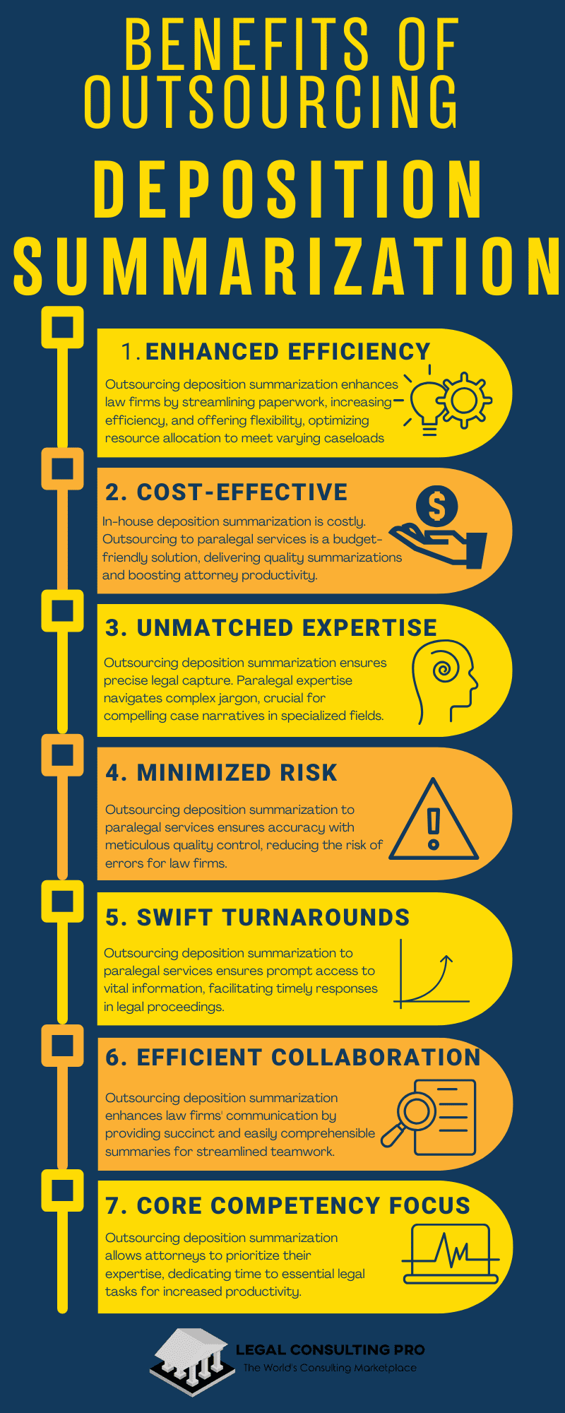Legal Consulting Pro Benefits of Outsourcing Deposition Summarization

Whether you require a deposition summary sample, deposition summary example, or a comprehensive digest of deposition proceedings, Legal Consulting Pro offers tailored solutions to suit your specific needs. With their expertise and dedication, they empower attorneys to navigate the complexities of litigation with confidence and clarity. By entrusting your deposition summary needs to Legal Consulting Pro, you can unlock a competitive advantage that propels your legal practice toward success.

Conclusion

Deposition summaries are indispensable assets in the legal toolkit, offering a blend of efficiency, clarity, and strategic advantage. By transforming voluminous deposition transcripts into streamlined, relevant summaries, they empower attorneys to focus on crafting compelling arguments and developing robust case strategies. The various types of summaries, from page-line to comprehensive digests, cater to different needs, ensuring that the information is both accessible and actionable. [Outsourcing these services to professionals like Legal Consulting Pro](https://legalconsultingpro.com/deposition-summarization/) not only saves time but also guarantees high-quality, accurate summaries that meet the demands of complex legal proceedings. Embrace the power of expertly crafted deposition summaries and elevate your legal practice to new heights of efficiency and effectiveness.